# Q1. Random plots using mvn_rnd function of 2-gaussians.

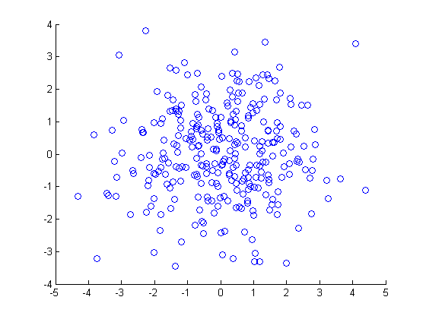

Clustering using mean_shift using sigma_x = sigma_y = 2

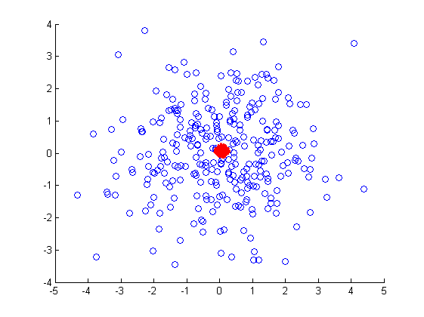

Minimum number of iteration for alpha(difference between two consecutive Xn = 0.01) = 2

Maximum number of iteration for alpha(difference between two consecutive Xn = 0.01) = 5

Avg. = 3.211